PROJECT NEEDS ASSESSMENT

**PIZZA SYSTEM**

**Submitted by:**

**Alex Wilber**

**CONTENTS**

|  |  |  |
| --- | --- | --- |
| 1 | INTRODUCTION | 3 |
| 2 | OBJECCTIVES AND SCOPE | 4 |
| 3 | SYSTEM SPACIFICATION | 5 |
| 4 | TOOLS, PLATFORM | 5 |
| 5 | SYSTEM DESIGN:   * PROCESS DIAGRAM * FLOW DIAGRAM | 6 |

**INTRODUCTION TO THE PROJECT**

This project is a simulation of taking of orders at a pizza takeout restaurant.

As the internet users are increasing exponentially, these companies have introduced Online Pizza ordering system for taking orders from customers. This system not only improves customer’s experience but also eases the workload on the staff of pizzerias.

The placeorder form is use to take order of pizza from user with full detail and after fill data click to the placeorder button. Page redirect to the confirmdata page and on this page user show detail about its order.

After the user see’s the details, the user will click on the confirm button which adds the order to the database.

**OBJECTIVE OF THE PROJECT**

In this world of growing technologies everything has been computerized. With large number of work opportunities the Human workforce has increased. Thus there is a need of a system which can handle the data of such a large number of data in an organization. This project simplifies the task of maintain records because of its user friendly nature.

It is a system design specific for small pizza management business. The user can view available pizzasize and the user can choose from available pizzas. The customer can easily learn the intuitive interface and order a pizza of their choosing. The major benefit of the system is that it reduces the major calculations of charges of buying a pizza.

**SYSTEM SPECIFICATION**

The aim of to develop **“Pizza Management”** website, which should automate the process to see and store details.

**TOOLS, PLATFORM AND LANGUAGE USED**

**FRONT END:**

The programming has been done using the ASP.NET. It is Microsoft base framework for platform independent programming. It is easy to use, efficient and flexible.

**BACK END:**

Microsoft SQL Server is one of the leading database management systems available on the market today.

**SYSTEM DESIGN**

**Process Diagram**

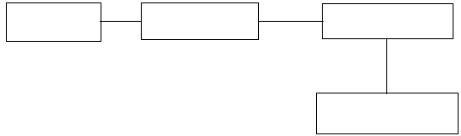

orderplace

Contact us

Home

confirm

**DATA FLOW DIAGRAMS**

**LEVEL 0 DFD:**



Pizza

Management

System

Store data

Insert data